LEGO Set: New York City Skyline

# Item #51

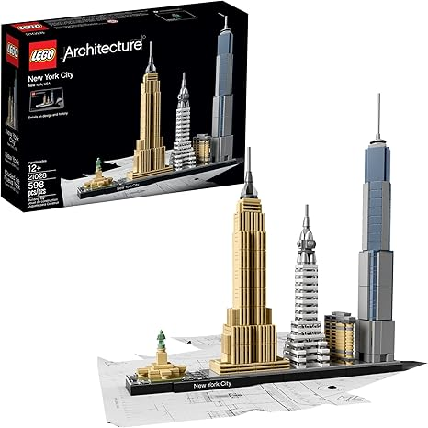

# Item Description: LEGO New York City Skyline Kit

Includes: 598 pieces and Building Booklet

Lending Guideline: 4 Week Check Out Time

Replacement Cost: $50

LEGO Set: Mini Orchid

# Item #52

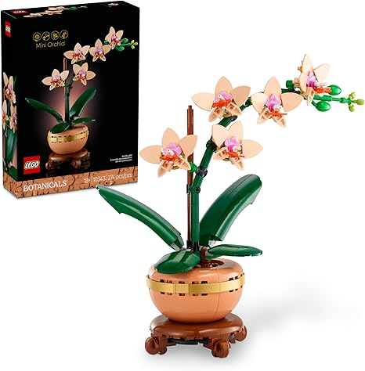

# Item Description: LEGO Mini Orchid Kit

Includes: 274 pieces and Building Booklet

Lending Guideline: 4 Week Check Out Time

Replacement Cost: $25

LEGO Set: Succulents

# Item #53

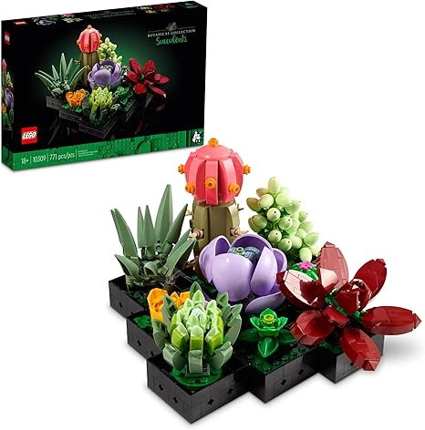

# Item Description: LEGO Succulents Kit

Includes: 771 pieces and Building Booklet

Lending Guideline: 4 Week Check Out Time

Replacement Cost: $50

LEGO Set: Bonsai Tree

# Item #54

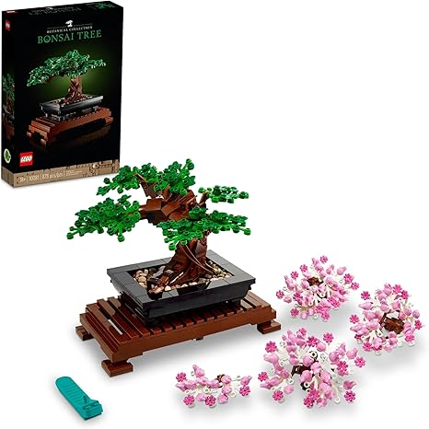

# Item Description: LEGO Bonsai Tree Kit

Includes: 878 pieces and Building Booklet

Lending Guideline: 4 Week Check Out Time

Replacement Cost: $50